Learn Turtle Graphics
Learn the basics of Python Turtle Graphics
Don Watkins

OVERVIEW & PURPOSE
The student will learn to install Python Idle3 and perform a ‘pip3’ install of Mu-Editor. The student will use Mu-Editor and Python code to create simple turtle graphics within the coding platform.

EDUCATION STANDARDS
- ISTE Learning Standard - 5a - Students formulate problem definitions suited for technology-assisted methods such as data analysis, abstract models and algorithmic thinking in exploring and finding solutions.

OBJECTIVES
- Students will learn how to install Python 3 Idle programming environment and to install the Mu-Editor from the terminal.
- Students will learn how to launch the Mu-Editor
- Students will learn how to load the ‘turtle library’ and write simple programming statements to move the turtle around the display.

MATERIALS NEEDED
- Linux Laptop
- Python 3, IDLE and Mu-Editor installed
- Access to the Internet

Instructions
- Install Python 3 and IDLE:
  - On Ubuntu the install is: $ sudo apt install idle3
  - On Fedora the install is: $ sudo dnf install python-tools
- After installing Python 3 and IDLE you will need to install Mu-Editor. This installation is completed in a terminal by entering the following command:
  - $ pip3 install mu-editor
- Launch Mu-editor by opening terminal and entering the following $ mu-editor
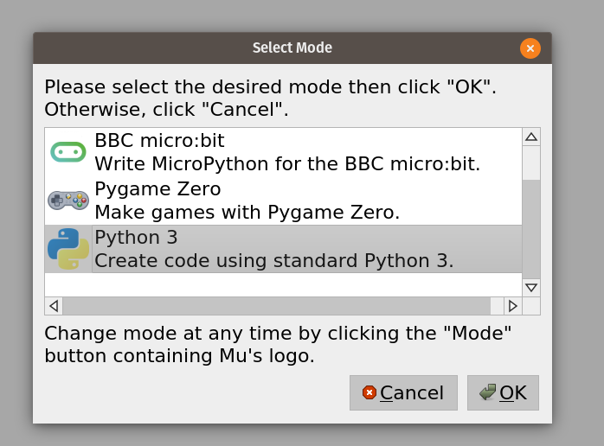
- Select Python 3 and then click ‘OK’. Then click on the “+” below to begin a new program.

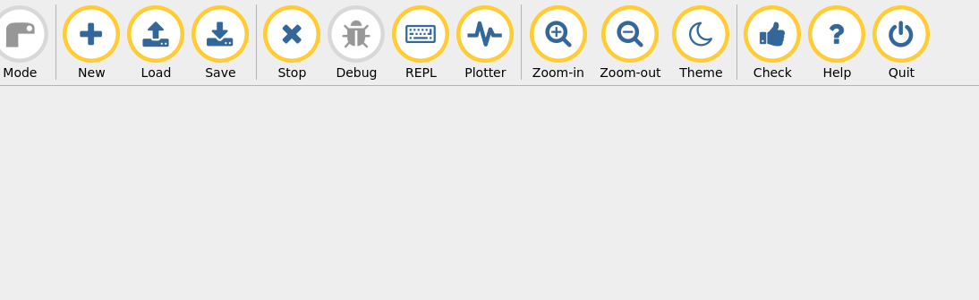
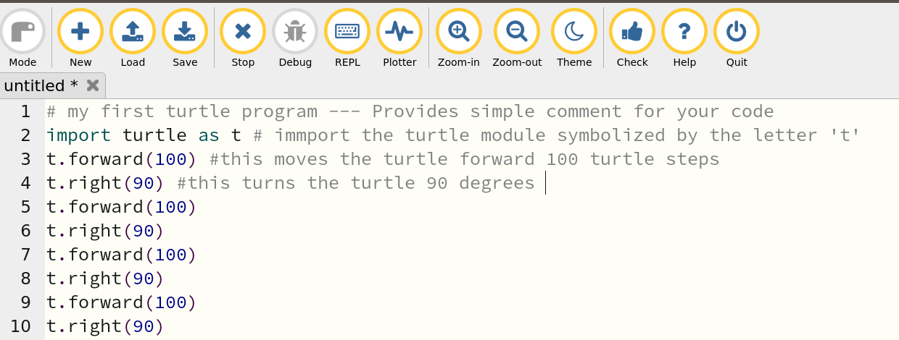
- Then enter your first program as shown above.
- Save the program by clicking on the ‘Save’ (Third button from the left)
- ‘Run’ the program.
- What happened? You should see a square drawn by the turtle.
- You can make changes to this program by adding more ‘turtle’ steps you can add more sides by decreasing the angle and adding more lines.
- An easy way to increase the complexity is by using a ‘for’ loop.
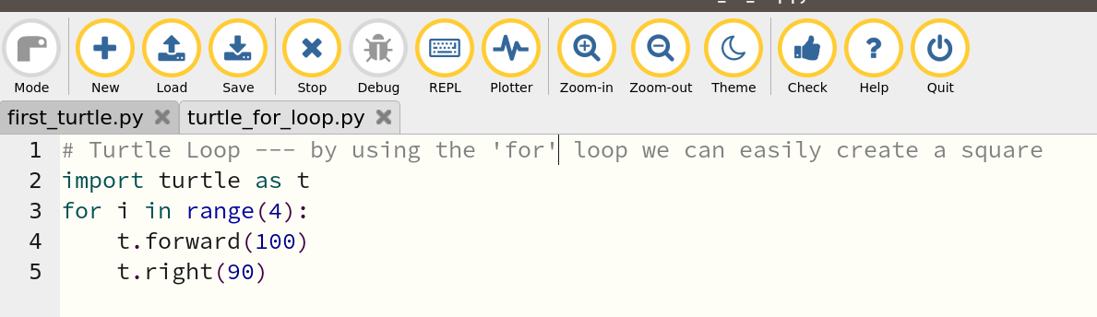
- Select ‘Save’ and then ‘Run’. What happened?

Further Study
Teach Your Kids to Code - Bryson Payne
Python for Kids - Jason R. Briggs

This work is licensed under a Creative Commons Attribution 4.0 International License.

